CHEMICAL ENGINEERING TRANSACTIONS  VOL. 2023 | A publication of
The Italian Association
of Chemical Engineering
Online at www.cetjournal.it

Guest Editors: David Bogle, Flavio Manenti, Piero Salatino
Copyright © 2023, AIDIC Servizi S.r.l.
ISBN 979-12-81206-04-5; ISSN 2283-9216
Design of evaporation ponds for the fractionated crystallization of minerals from desalination brines
F. Vicari^{a*}, R. Cucchiaraª, M. Bevacquaª, E. Bautista-Salinas^{b}, J. Arévalo-Vilches^{b}, A. Cipollina^{c} , G. Micale^{c}, V. Monsalvo-Garcia^{b}, A. Tamburini^{c},

ªResourSEAs srl, Palermo, Italy
^{b}Departamento de Innovación y Tecnología FCC Aqualia, Madrid, Spain
^{c} Dipartimento di Ingegneria, Università di Palermo (UNIPA), Palermo, Italy
e−mail: fabrizio.vicari@resourseas.com

The evaporative crystallization of minerals in saltworks is one of the oldest industrial processes still in operation and has the potential to achieve high solar energy conversion efficiencies. While salt production from seawater has been extensively studied, the circular economy of brines exploitation is opening new fields of investigation. This article focuses on the design and simulation of a process for selective precipitation and mineral recovery from reverse osmosis brines. The process involves a two-step evaporative system followed by reactive crystallization of magnesium hydroxide. Laboratory tests and simulations using PHREEQC (pH-REdox-Equilibrium C-program) were conducted to validate the thermodynamics of the process and forecast the optimal operative conditions.
- Introduction
Directly powered by wind and sun, the evaporative crystallization of minerals in saltworks is the most ancient industrial process currently operated. Solar energy conversion efficiency in these places can theoretically reach values of 45 % (Sedivy, 2009), being the highest value deployable for a Technology Readiness Level of 9.
Saltworks behaviour during the evaporation of seawater has been thoroughly studied by many scientists that have evolved descriptive and predictive models for the production of table salt. However, the rising of the circular economy of brines is opening new fields of investigation related to the perspective integration with other processes to gain synergic effects as in the case of desalination (Cipollina et al., 2012). Recently, it was also pointed out that saltworks may be seen as a source of primary and critical raw materials, showing how hydrogeological tools can be used to understand the faith of the ions of interest (Vicari et al., 2022).
In the present work, an additional effort has been made to combine the description of minerals crystallization with evaporation models for the prediction of minerals production in a pilot saltwork fed with concentrated reverse osmosis (RO) brines. At the lab-scale, the measured concentrations of major ions in solution (such as Na, Mg, K, Cl and SO₄) during water evaporation and minerals deposition at 40 °C and 120 °C were compared to thermodynamic simulation results, finding negligible differences for concentration factor (CF) up to 20. The validated thermodynamic package has been merged with a model for the prediction of the evaporation rate on the planned installation site for the REWAISE H2020 project Mediterranean Case at Aqualia premises in Adeje, Santa Cruz de Tenerife, Spain (www.rewaise.eu).
Using the actual meteorological data for the installation site, a preliminary design of the evaporative ponds has been given, along with a quantitative description of the expected performances; with a total evaporative surface of 376 m², a peak productivity of 12 kg/d of calcium salts and 270 kg/d of NaCl is expected for the REWAISE pilot installation.
The project will contribute to the community by producing several impacts on different fields, including benefit the European Union by generating know-how in terms of patents and publications; safeguarding environmental sustainability by increasing energy and water efficiency and reducing wastewaters and emissions; create innovative technologies that will help unlock substantial reserves of new currently unexploited resources within EU.
The focus of this work is to design and simulate a process for the selective precipitation and recovery of salts in the retentate, both through physical and chemical interactions. The results obtained by laboratory tests have been compared with the ones obtained by simulations using the software PHREEQC.
This section has been divided into three sub-chapters concerning (i) evaporation tests conducted at lab-scale; (ii) simulations with PHREEQC; (iii) tests conducted with a lab-scale plug flow crystallisation reactor.
- Materials and methods
Figure 1 describes a scheme that wants to simulate a process to exploit the retentate exiting the RO plant. The process involves a two-steps evaporative system, to precipitate Limestone (CaCO₃) and Gypsum (CaSO₄) first, then Halite (NaCl); a final step consists of the reactive crystallization of magnesium hydroxide achieved with the addition of an alkaline reactive to the brine.

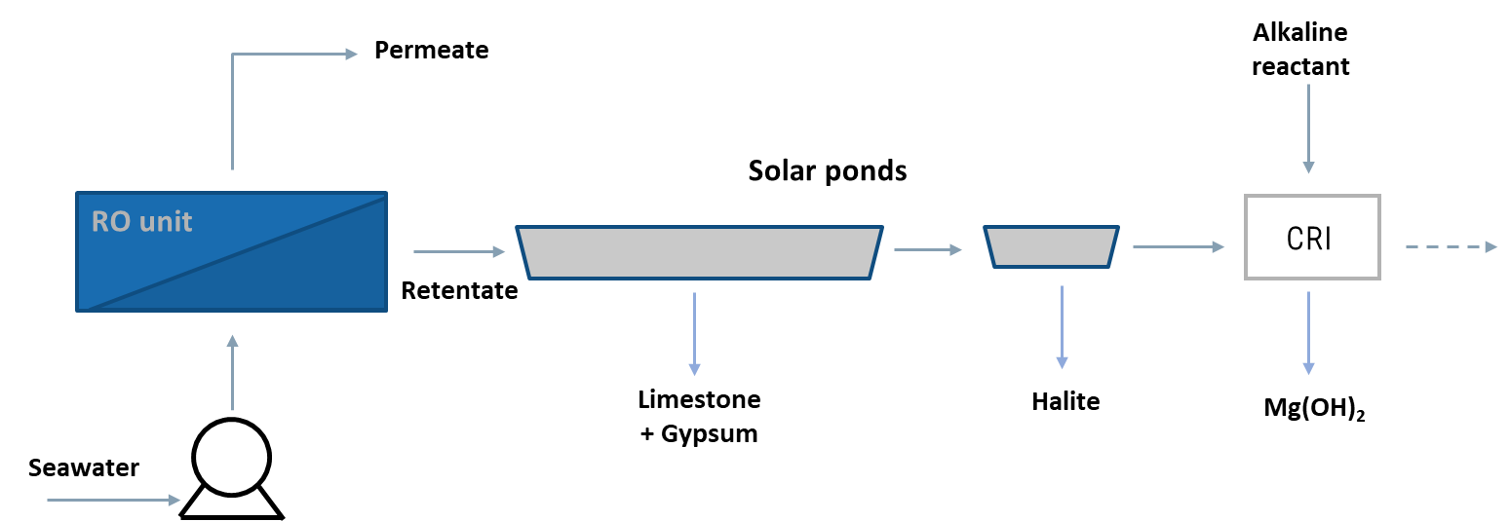
Figure 1: Process scheme.
2.1. Physical properties
The brine samples used for the experiments were characterized using the following parameters.
To measure density 10 ml of brine was transferred into a volumetric flask, which was weighed before and after being filled with the brine. Density was simply calculated as mass and volume ratio considering the weight of the volumetric flask.
pH and conductivity were simply measured experimentally respectively using a glass electrode probe and a conductivity probe, which were bathed in the brine.
At last, the ionic composition was evaluated by ion chromatography (Metrohm 882c).
2.2. Evaporation tests
The brine used for the evaporative experiment activities was collected in Adeje (Tenerife, Spain) and supplied by Aqualia, within the European project REWAISE.
Since the amount of the brine from Adeje was limited, also an artificial brine was prepared and used for the experimental campaign. The artificial brine had a composition equal to the one from Adeje (Table 1).
An additional evaporation test has been carried out to assess the effect of an antiscalant, supplied by Aqualia, on the evaporation process.
Table 1: Adeje brine composition.
 | Na⁺ | K⁺ | Mg²⁺ | Ca²⁺ | Cl⁻ | SO₄²⁻ | TDS
g/l | 18.925 | 0.729 | 2.100 | 0.419 | 34.941 | 5.092 | 62.205

For the tests 1 l of brine was transferred in a glass crystallizer and then put into the oven (Argo Lab, TCN50 plus). The first test was conducted at 120 °C, then the following tests at 40 °C to emulate the condition of a real evaporative environment.
The properties of the brine were monitored during the test, dividing it into steps, separated by fixed concentration factor (CF), at which the residual volume was measured, and liquid samples of 15 ml were collected. The samples were analysed to obtain the ionic composition, pH, conductivity, and density, while the evaporation went on. The concentration factor (CF) was calculated as the ratio between the initial volume and the volume after the evaporation.
The right residence time, which corresponds to a specific CF, ensured the precipitation of all calcium (as CaCO₃ and CaSO₄) and then sodium (as NaCl) while the evaporation of the liquid occurred.

Different tests have been carried out changing the operative conditions, which are reported in Table 2.

Table 2: Operative conditions for the evaporation tests.
 | Sample | Temperature | Antiscalant | Residency time
Test 1 | Real Brine | 120 °C | - | ~ 10 hours
Test 2 | Real Brine | 40 °C | - | ~ 200 hours
Test 3 | Artificial Brine | 40 °C | - | ~ 200 hours
Test 4 | Artificial Brine | 40 °C | 1.2 mg/l | ~ 200 hours
2.3. PHREEQC simulation
During this work, PHREEQC has been extensively validated against laboratory experiments and field observations, making it a trusted tool for predicting chemical speciation and reaction rates in natural waters. Furthermore, it was tested against literature data to verify the adherence and coherence of the results related to crystallization of salts during seawater evaporation. The design and simulation were performed focusing on crystallizations phenomena to perform calculations under different operative conditions.
2.4. Crystallization reaction
The brine from a real saltworks operating in Trapani (Italy) was used for this part of the experimental campaign in substitution of the one from Adeje which was not sufficient for all the tests. The brine has 30 g/l of Mg²⁺ and the amount of total dissolved salts (TDS) was very close to the expected one exiting the last evaporation pond.
Solutions of sodium hydroxide (NaOH), calcium hydroxide (Ca(OH)₂), sodium carbonate (Na₂CO₃) and ammonia (NH₃) were used as alkaline reactant. An accurate evaluation has been carried out to choose the best one to precipitate magnesium hydroxide, in terms of conversion, purity and costs.
Since they had different [OH⁻] concentrations the flow rate was calculated to have a stoichiometric condition with Mg²⁺ to recover the total magnesium present in the brine. All the operative conditions are listed in Table 3.
Table 3: Operative conditions adopted during the experimental campaign.
Test | Reactant | Brine Concentration  [mol/l] | Brine Flowrate  [ml/min] | Molar Ratio  N_{base}/N_{stoic}* | Base Concentration  [mol/l] | Base Flowrate per inlet  [ml/min]
A | NaOH | 1.25 | 47 | 1 | 4 | 7.35
B | Ca(OH)₂ | 1.25 | 47 | 1 | 2 | 7.35
C | Na₂CO₃ | 1.25 | 47 | 1 | 2 | 7.35
D | NH₃ | 1.25 | 47 | 1 | 14.7 | 1.81
* N_{base}/N_{stoic} = molar ratio between the amount of base reactant used for the test and the stoichiometric amount.

The crystallization reactor used for the final step of the process, is a cylindrical plug flow reactor (PFR). The PFR used in the experimental campaign had one inlet for the feed brine and several inlets for the alkaline reactant (Bevacqua et al., 2021).
prior to the test, the selected reagents were characterized in terms of volume to be used and solution concentration. Samples of 150 ml were collected for further analysis.
The suspension samples were analysed using laser granulometer (Malvern Mastersizer 2000 with Hydro 2000MU as sample dispersion system) to obtain a cumulative size distribution (CSD) of crystal agglomerates; and also, by optical microscope (Optika B-800), to assess how different reactants can produce agglomeration crystals with different shape.
By filtration the solid product was separated from the liquid phase; the solid was then washed with distillate water and dried in oven at 130 °C for 24h. Both the liquor and the solid were analysed by ion chromatography.
- Results
This section summarizes the results obtained from the evaporation tests, the simulations performed with PHREEQC, and the tests with the crystallization reactor.
  - Evaporation tests
    - Temperature’s effect on evaporation
As already shown in Table 2, the effect of temperature was investigated during the evaporation carried out using the Real Brine from Adeje. Figure 2 shows the comparison in composition of the major cations and anions during the evaporation under different temperatures.
Calcium constantly decreases its concentration, meaning that its salts precipitate. Sodium concentration increases at first but then starts to decrease at CF around 6 at which point the precipitation of sodium chloride starts.
B
A
Figure 2: Comparison of major cations (A) and anions (B) concentration for Real Brine evaporation at 40 and 120 °C.
The increase of temperature enhances the solubility of Na⁺, Mg²⁺ and K⁺. It could be noticed that calcium concentration goes to zero at 120 °C, but fails to precipitate completely at 40 °C, where calcium remains partially in solution. Both Cl⁻ and SO₄²⁻ seem to increase their solubility when the brine is heated at 120 °C, while at the same CF conditions they precipitate at 40 °C.
    - Effect of antiscalant on evaporation
The effect of antiscalant was evaluated at 40 °C, to assure slow evaporation and to create a condition as similar as possible to the real process of solar evaporation. Since the amount of brine from Adeje was not sufficient, an artificial solution has been prepared to reproduce the same composition as the original one. To one of them 1.2 mg/l of antiscalant was added.
B
A
Figure 3: Comparison of major cations (A) and anions (B) concentration for Artificial Brine evaporation with and without the addition of 1.2 mg/l of antiscalant.
As shown in Figure 3 the presence of antiscalant to the brine does not significantly affect the evaporation process. In fact, the concentration trends for both tests are almost overlapping. The only exception concerns calcium, for which, in the presence of antiscalant, the concentration remains higher, slightly slowing down the precipitation of its salts.
  - Model validation
    - Experimental results with PHREEQC simulations
The results obtained from the experiments conducted on evaporation were compared with the output given by the simulations from PHREEQC, as shown in Figure 4. For the experimental results the average values from Test 1 and Test 2 were considered (see Table 2). As it emerges from the figure, the trends in compositions are quite similar up to CF values of 20.
Figure 4: Comparison of the concentrations of the major cations between experimental with real brine (average values) and simulation with PHREEQC.
B
A
    - Crystallization sequence prediction
Figure 5 highlights that for CF between 0 and 2.2, the brine concentration is still too low, so crystallization does not occur. Starting at CF equal to 2.2, where the brine has a concentration of 116 g/l, calcium salts start to precipitate up to CF equal to 6.2, where the concentration is 323 g/l. Finally, for CF over 6.2, sodium chloride precipitation occurs. The brine exiting the last pond reaches a concentration of 328 g/l.
Figure 5: Trend of salts crystallisation sequence increasing the concentration factor.
These results from PHREEQC were used to design a possible scheme of evaporating ponds as the one shown in Figure 6. Meteorological data from Adeje have also been used, to predict the evaporation rate in mm/d.
It is possible to divide the set of ponds into two large units, respectively for calcium and sodium salts. The first unit consists of 6 ponds (2.2 < CF < 6.2), the second unit consists of two ponds, each one present in triplicate (CF 7.5 and 8.5). The ponds become smaller and smaller as the volume of brine decreases due to evaporation.

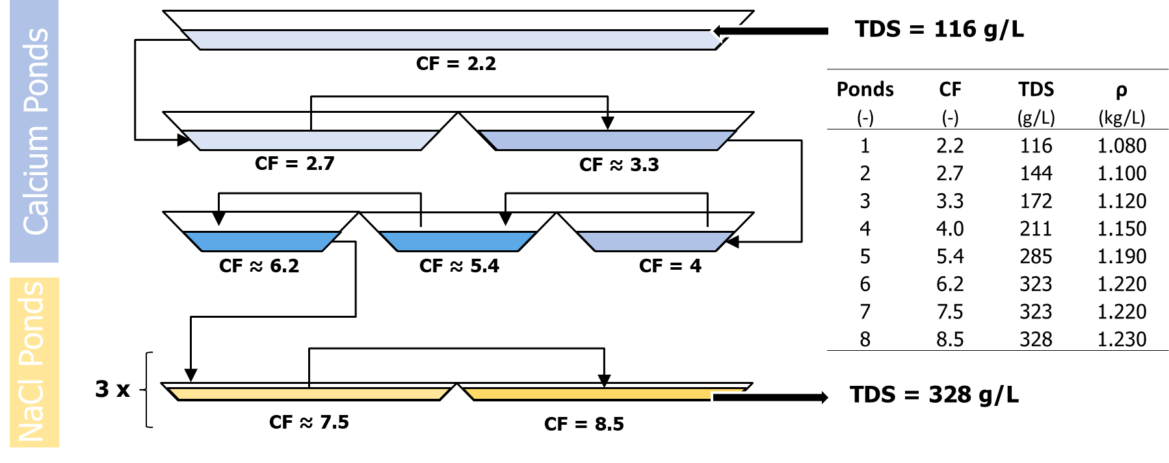
Figure 6: Scheme of evaporating ponds according to simulations from PHREEQC
  - Crystallization reactor
The performances of each solution were analysed considering as main indicators the trend of pH, the percentage of conversion and purity of the final product. Only strong bases reached expected quantitative conversion. Sodium carbonate stops at 85%, while an even lower conversion is observed with ammonia (Figure 7.A). Purity determines the commercial value of the product. All tests reach purity over 95%, but for the case of Calcium hydroxide suspension, likely due to the co-precipitation of insoluble calcium salts (Figure 7.B).
A
B
Figure 7: A) Conversion at the end of reactor. B) Solid purities found in the tests in terms of Mg²⁺. Brine Mg²⁺ concentration = 1.25 mol/l; Brine flowrate = 47 ml/min; N_{base}/N_{stoich} =1. NaOH concentration = 4 mol/l; Ca(OH)₂ concentration = 2 mol/l; Na₂CO₃ concentration = 2 mol/L; NH₃ concentration = 14.7 mol/l.
- Conclusions
The present study has investigated the behaviour of brine during evaporation and crystallization through experiments and PHREEQC simulation. The evaporation tests showed that change in temperature or the addition of antiscalant did not significantly affect the evaporation behaviour. The experimental results were compared with PHREEQC simulations, and a good agreement was observed in terms of the major ion concentrations. From these simulations a scheme of evaporating ponds was predicted and designed. At last, experiments were conducted in a laboratory-scale continuous Plug Flow Reactor to evaluate the effect of using different alkaline reactants to produce magnesium hydroxide. Sodium hydroxide solutions have led to a product purity higher than 95% and complete conversion for Mg²⁺ in the brine. Calcium hydroxide lowers product purity to almost 50%, thus being not suitable for this purpose. Sodium bicarbonate allows to recover magnesium in two different forms, as hydroxide and carbonate. The higher average diameter of particles improves filtration capability of the system, though no high purity in Mg(OH)₂ can be expected. Finally, ammonia leads to a high purity product, though the weakness of the base, along with dilution phenomena generated by the direct mixing with the brine makes it impossible to reach a quantitative recovery of magnesium.

Bevacqua, M. et al. (2021) ‘Reattore e processo di precipitazione di un prodotto solido’. Italy.

Cipollina, A. et al. (2012) ‘Integrated production of fresh water, sea salt and magnesium from sea water’, Desalination and Water Treatment, 49(1–3), pp. 390–403. doi: 10.1080/19443994.2012.699340.

Sedivy, V. M. (2009) ‘Environmental balance of salt production speaks in favour of solar saltworks’, Global Nest Journal, 11(1), pp. 41–48. doi: 10.30955/gnj.000567.

Vicari, F. et al. (2022) ‘Mining minerals and critical raw materials from bittern: Understanding metal ions fate in saltwork ponds’, Science of the Total Environment, 847(March), p. 157544. doi: 10.1016/j.scitotenv.2022.157544.

